**Project Name: Retrieving the Product Details Using the Product ID**

**Developer Name:** Kapil Davey

**GitHub Link:-** [**https://github.com/kapildavey/Phase-2.git**](https://github.com/kapildavey/Phase-2.git)

**Creating table:-**

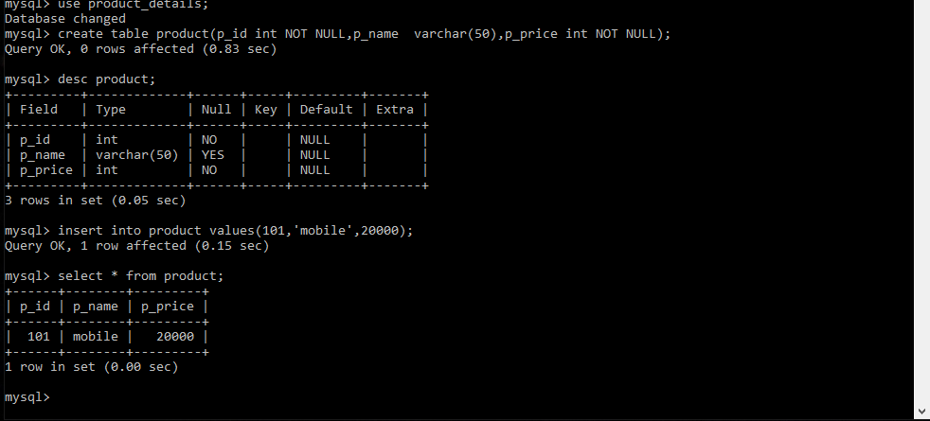

**Retrieving the Product Details Using the Product ID**

